ASSIGNMENT 2
BHAVLEEN KAUR

1.Git Setup https://confluence.atlassian.com/bitbucket/set-up-git-744723531.html
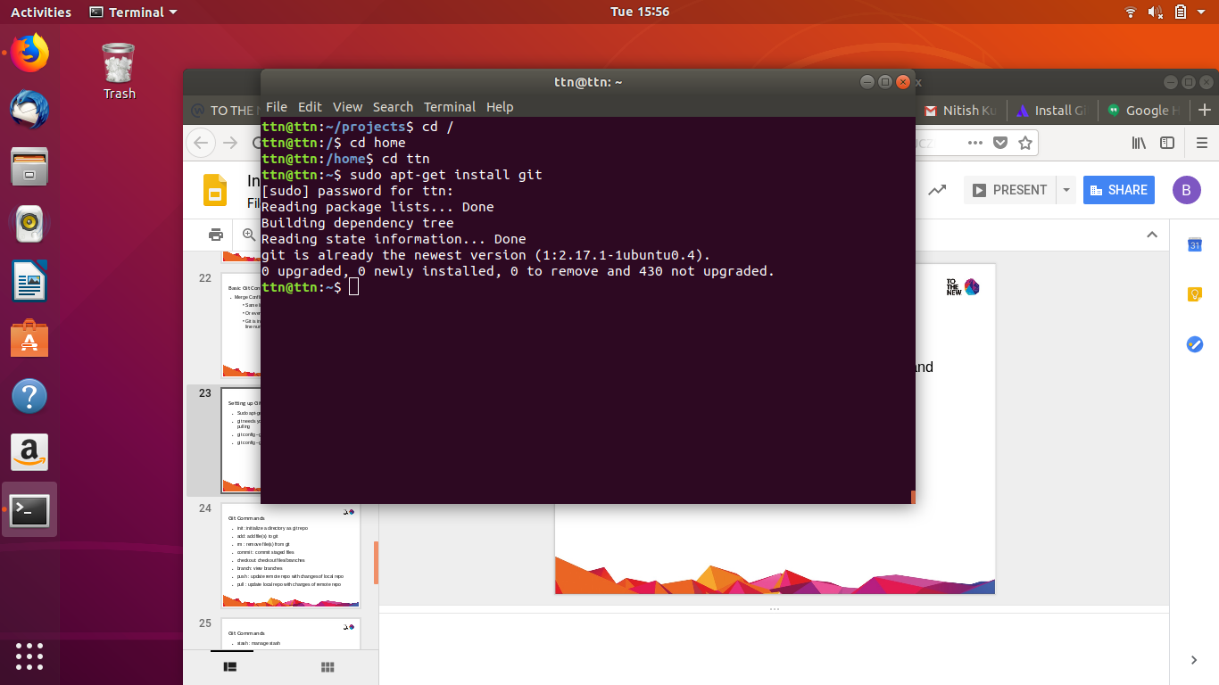

2.Initialize a Git Repository
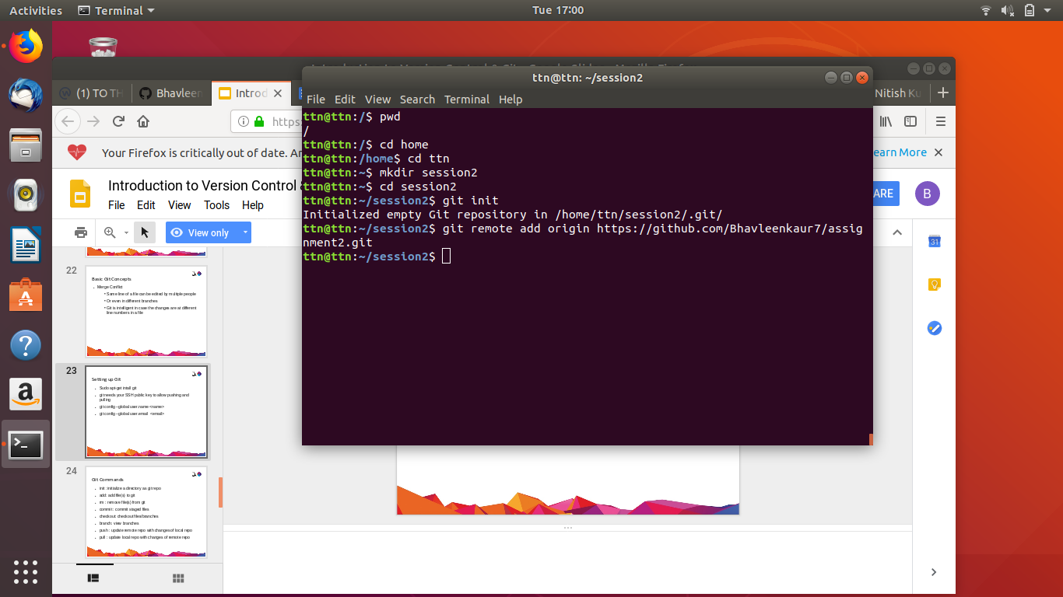

3.Add files to the repository
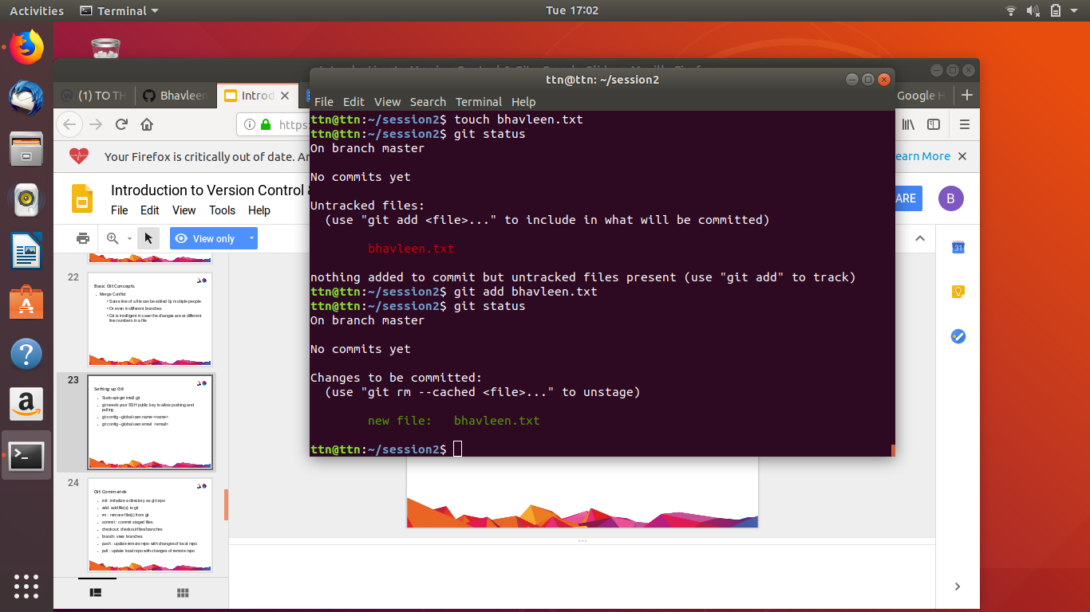

4.Unstage 1 file
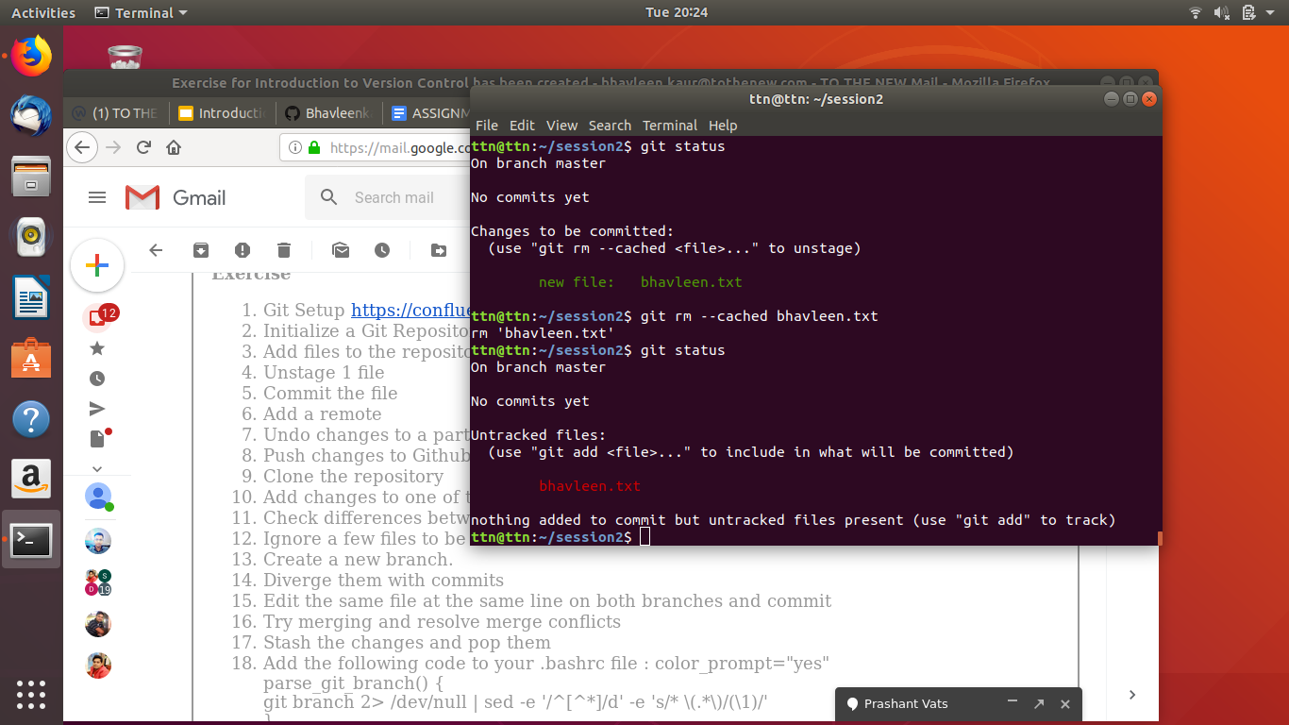

5.Commit the file
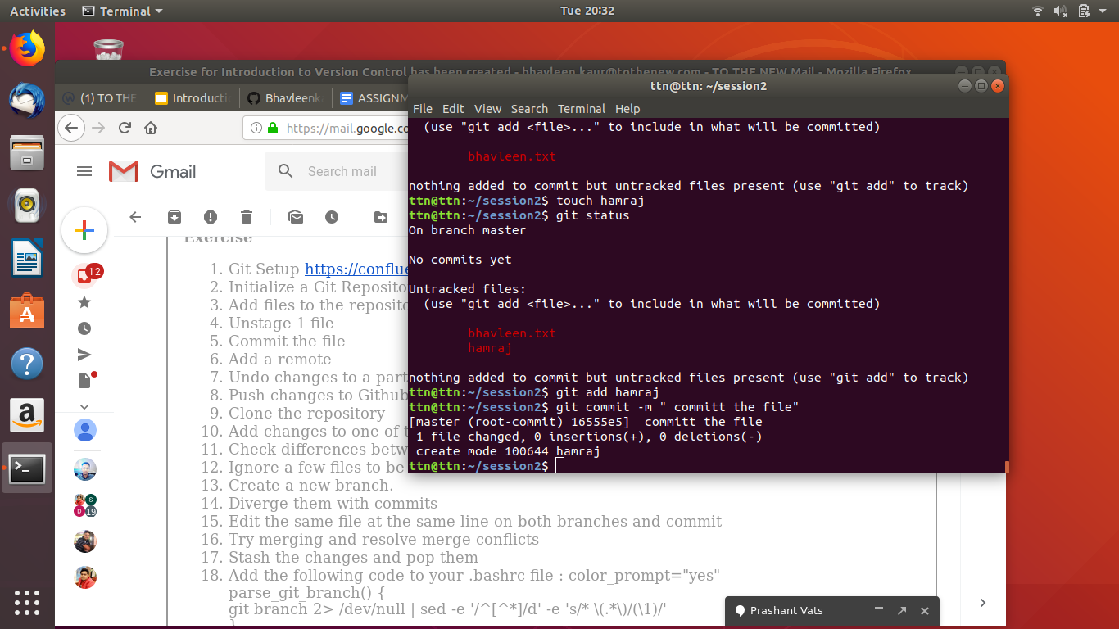

6.Add a remote
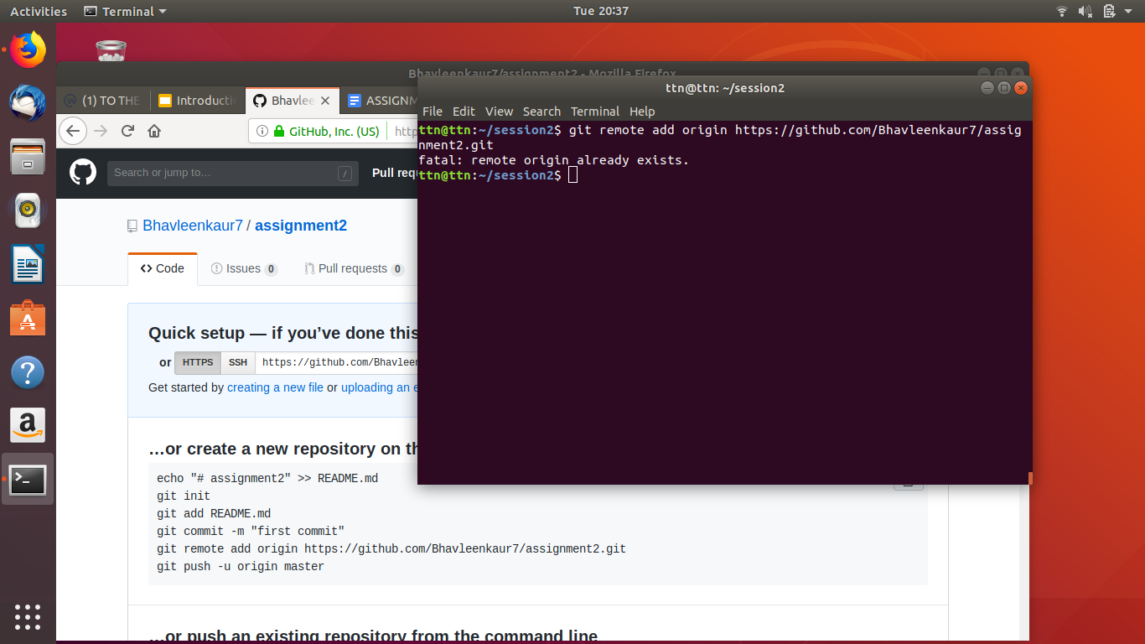

7.Undo changes to a particular file
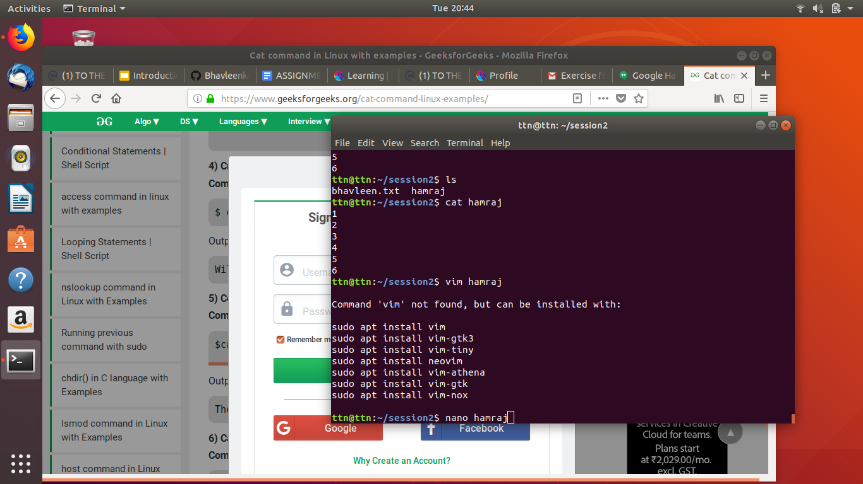

8. Push changes to Github
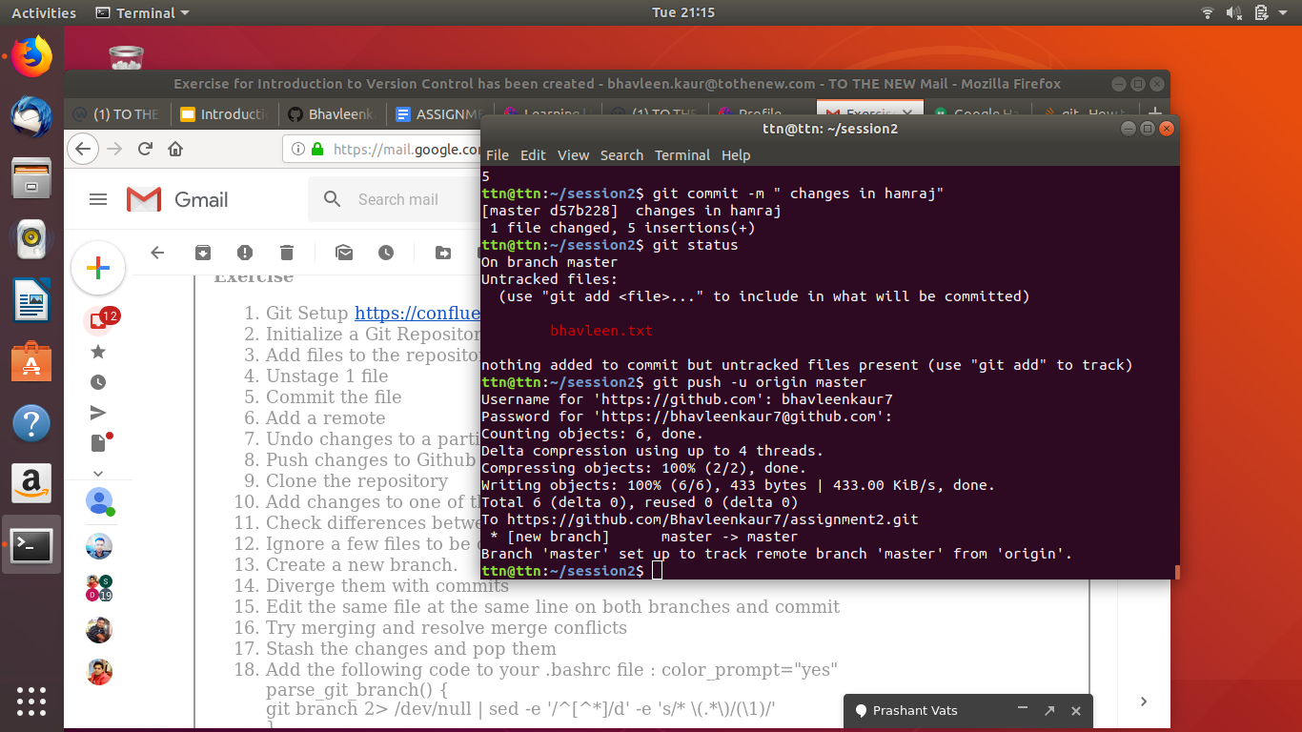

9.Clone the repository
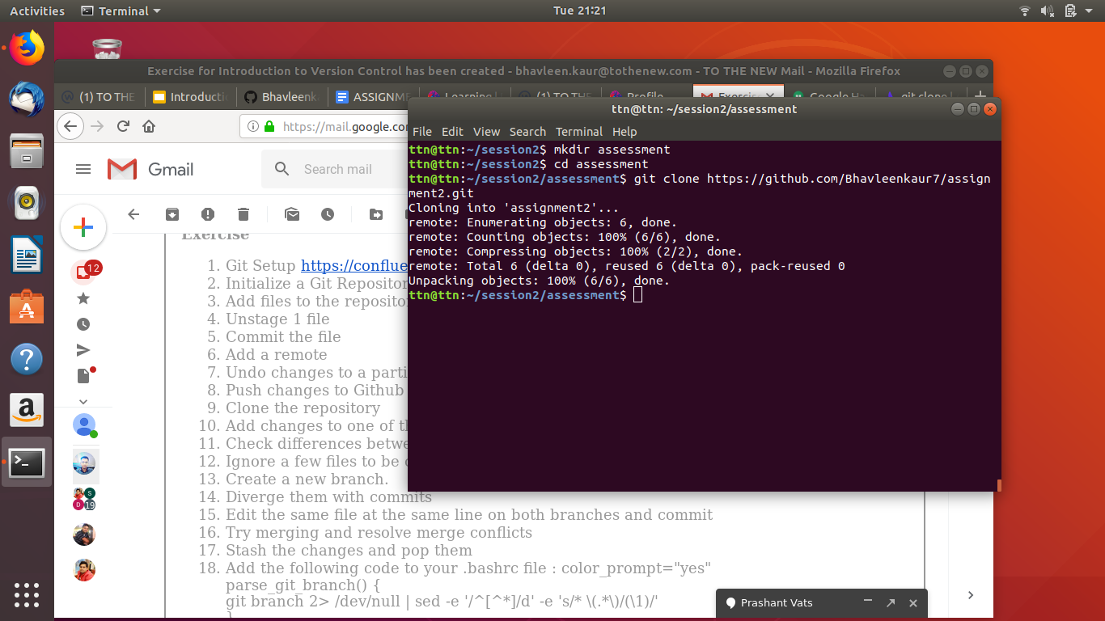

11.Check differences between a file and its staged version
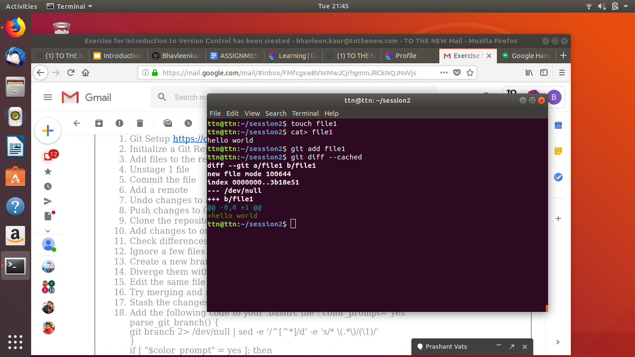

12.Ignore a few files to be checked in
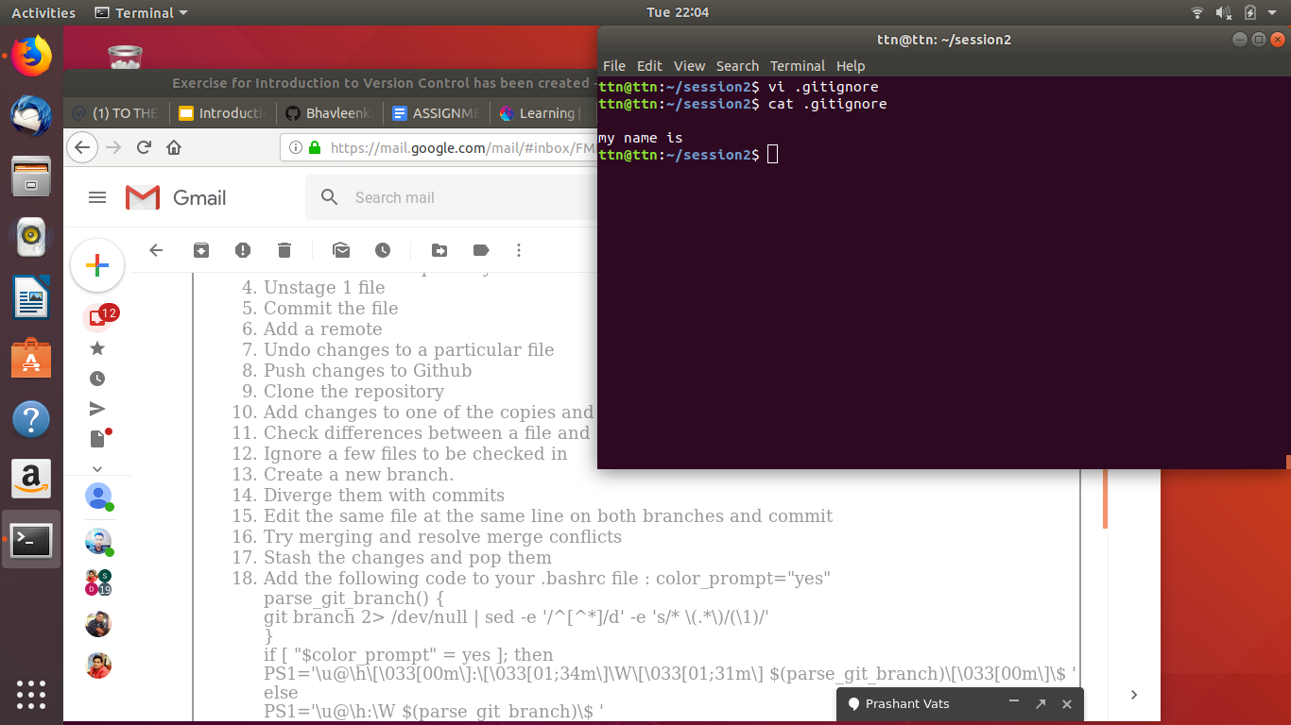

13.Create a new branch.
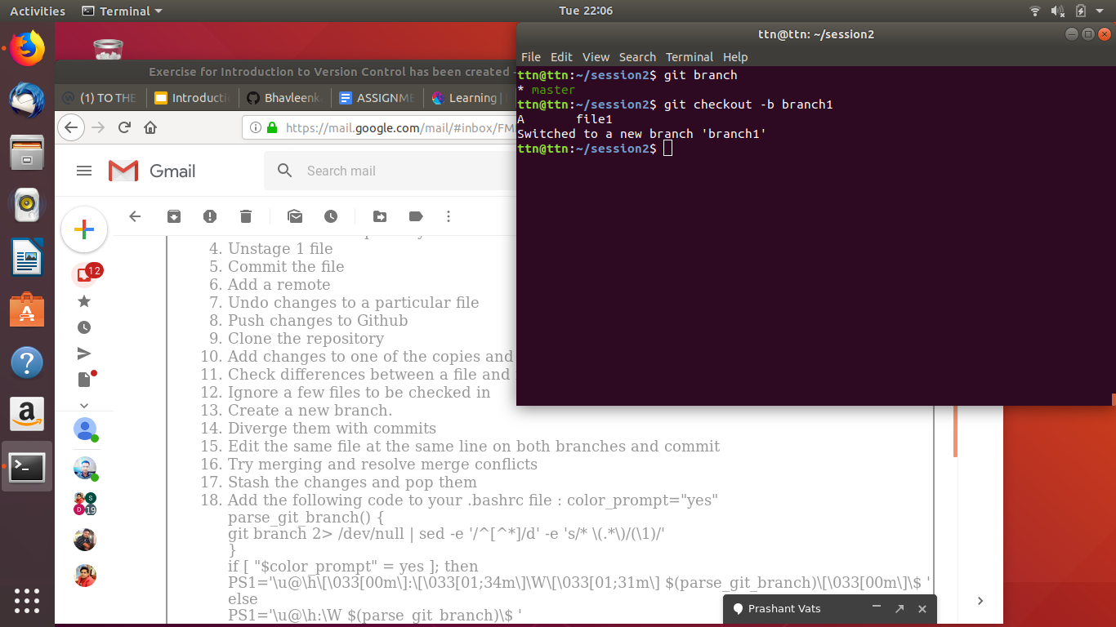

14.Diverge them with commits
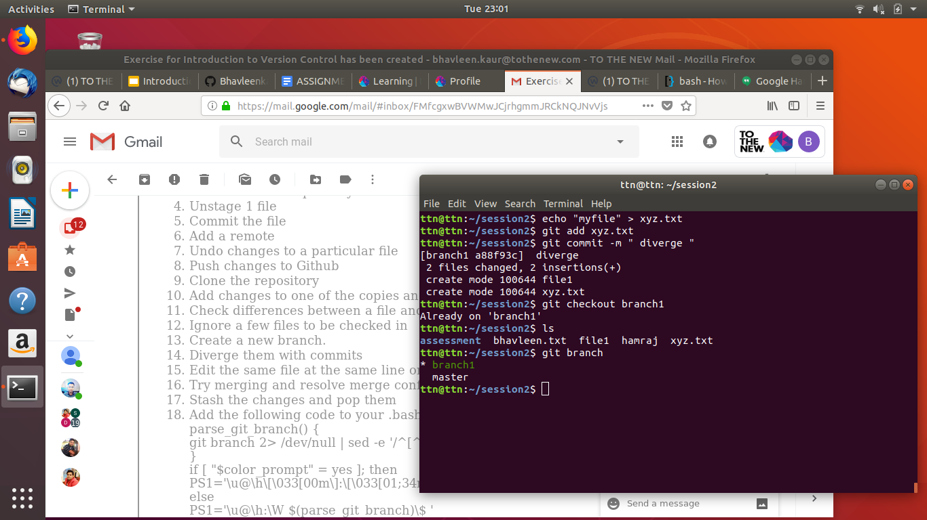

18.Add the following code to your .bashrc file : color_prompt="yes"
parse_git_branch() {
git branch 2> /dev/null | sed -e '/^[^*]/d' -e 's/* \(.*\)/(\1)/'
}
if [ "$color_prompt" = yes ]; then
PS1='\u@\h\[\033[00m\]:\[\033[01;34m\]\W\[\033[01;31m\] $(parse_git_branch)\[\033[00m\]\$ '
else
PS1='\u@\h:\W $(parse_git_branch)\$ '
fi
unset color_prompt force_color_prompt
